**Task 1 (a)**

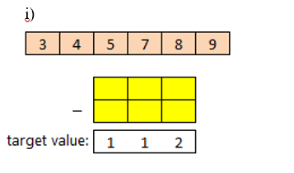

**Answer (i)**

|  |  |  |
| --- | --- | --- |
| **9** | **4** | **7** |
| **8** | **3** | **5** |
| **Target Value** | | |
| **1** | **1** | **2** |

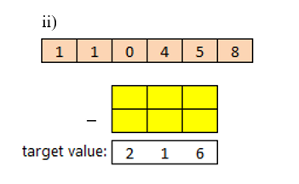

**Answer 1 (ii)**

|  |  |  |
| --- | --- | --- |
| **4** | **0** | **1** |
| **1** | **8** | **5** |
| **Target Value** | | |
| **2** | **1** | **6** |

Task 1 (iii)

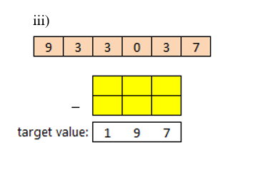

Answer (iii)

|  |  |  |
| --- | --- | --- |
| **9** | **3** | **0** |
| **7** | **3** | **3** |
| **Target Value** | | |
| **1** | **9** | **7** |

Task 1 (iv)

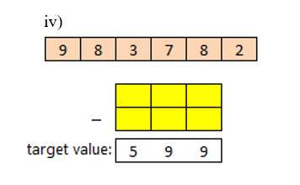

Answer (iv)

|  |  |  |
| --- | --- | --- |
| **9** | **7** | **8** |
| **3** | **8** | **2** |
| **Target Value** | | |
| **5** | **9** | **6** |

The smallest difference is 3 i.e., Target minus Calculated = 599 – 596 = 3

Answer 2:

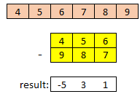

|  |  |  |
| --- | --- | --- |
| **4** | **5** | **6** |
| **9** | **8** | **7** |
| **Target Value** | | |
| **–5** | **3** | **1** |

Thus, the biggest difference would be generated with the following arrangement (456–987) difference is: target – calculated which is 654.

Therefore, single unique arrangement is there which produce the biggest difference.

**BONUS TASK**

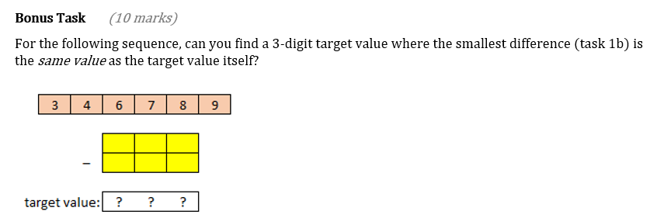

Answer:

|  |  |  |
| --- | --- | --- |
| **4** | **8** | **9** |
| **3** | **6** | **7** |
| **Target Value** | | |
| **1** | **2** | **3** |

So, the above table present an arrangement of 6 numbers that produces the smallest difference i.e., 1.

On the other hand, we can also find an arrangement where is no difference in between the calculated result and the target value (see below table).

|  |  |  |
| --- | --- | --- |
| **4** | **9** | **8** |
| **3** | **7** | **6** |
| **Target Value** | | |
| **1** | **2** | **2** |

If arrangement of 6 number is 498-376, then there is no small difference or exactly match with the target value.